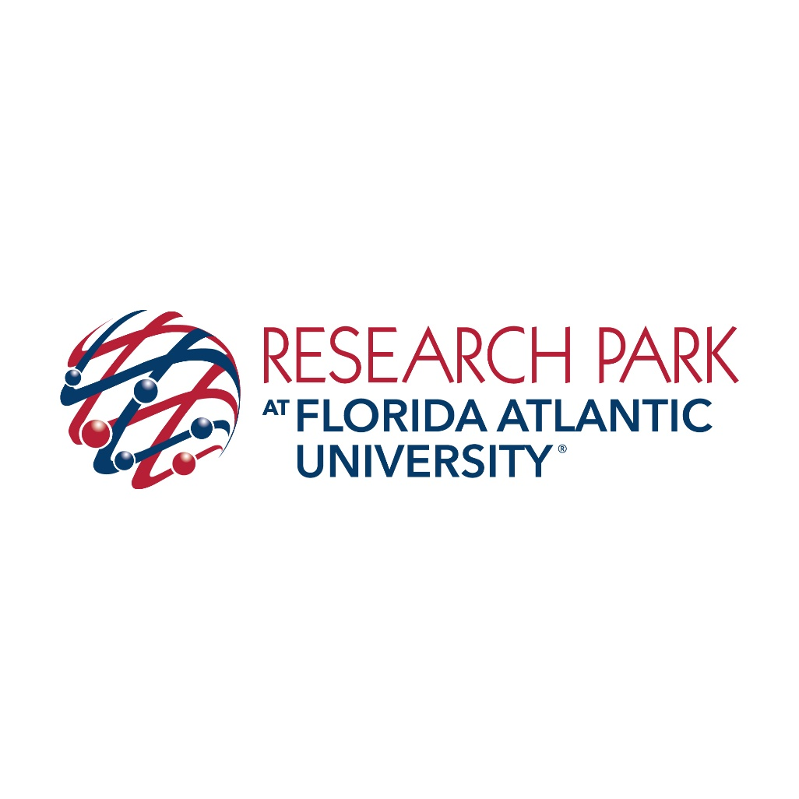

FLORIDA ATLANTIC RESEARCH AND DEVELOPMENT AUTHORITY

REGULAR MEETING AGENDA

3651 FAU Blvd., Suite 400 November 4, 2020
Boca Raton, FL 33431 9:00 AM

Chairman Bob Swindell
Vice Chairman Daniel Flynn
Member Michael Daszkal
Member Michael Allison
Member Fred Yentz
Member Francis Salazar
Member Sherry Ambrose

AGENDA
- Call to order & roll call
- Agenda approval
- Discussion of current tenant recruitment and approvals process
- Matters by the public
- Adjourn
Prior to consideration of a motion to approve any matter on the regular business section of the agenda, the Chair shall provide for public comment. Any member of the public may, in turn, make public comment from the podium for a maximum of three (3) minutes. General comment or new subject matter should be addressed in the matters by the public section of the agenda. Speakers should state their name clearly for the record.
Attendees with special needs can be accommodated by contacting the FARDA office at least two (2) business days prior to a meeting at (561) 416-6092 or info@Research-Park.org.

Notice pursuant to Florida Statute 286.0105: If any person decides to appeal any decision made by the Authority with respect to any matter considered at any of its meetings, he or she will need a record of the proceedings, and for such purpose he or she may need to ensure that a verbatim record of the proceedings is made, which record includes the testimony and evidence upon which the appeal is to be based.

2020-2021 Meeting Dates
Wednesday October 21st, 2020
Wednesday December 16th, 2020
Wednesday February 24th, 2021
Wednesday, April 21st, 2021
Wednesday June 23rd, 2021
Wednesday August 25th, 2021

All meetings at 8 AM unless otherwise noted
The Authority reserves the right to change these dates at its discretion and to add new dates as needed, subject to the requirements of applicable law.

